Tracing the Roman border
Explore history in the forests near Friedberg and Butzbach
By Karl Weisel
U.S. Army Garrison Hessen Public Affairs Office
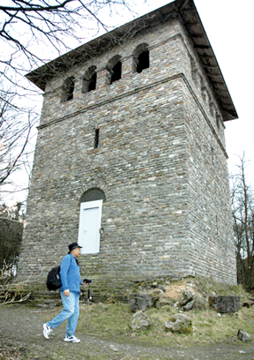
Roman history buffs needn’t go far to find traces of the border of the Roman Empire which ran through many of the areas where American Soldiers and their families reside today.
Remnants of the empire’s northern border — the Limes — recognized by the United Nations Educational, Scientific and Cultural Organization as a world heritage site, are still visible in the forests near Friedberg and Butzbach, and in many of the towns along the former border.
While many Americans are familiar with the reconstructed Saalburg fortress in the Taunus Mountains near Wehrheim above Bad Homburg, they may not realize they can retrace the Limes for hundreds of miles on foot or by bike throughout the countryside. Marked trails, a raised earth mound barrier, reconstructed towers and unearthed foundations are situated all along the Limes trail.
In the Saalburg visitors can get an impression of what it must have been like to serve as a Roman soldier some 2,000 years ago while guarding the empire against its enemies to the north. The Saalburg, the only fully reconstructed fortress along the 550-kilometer Limes in Germany which runs through the four states of Hessen, Rheinland-Pfalz, Baden-Württemberg and Bavaria, features an extensive museum with Roman artifacts, depictions of soldiers’ quarters and a host of buildings used in daily life. A small cafe, the Taberna, is also situated within the fortress.
The Saalburg is open daily from 9 a.m. to 6 p.m. March through October. Admission is €3 for adults, €2 for children and €7.50 for a family ticket (two adults and two children). Call civ (06175) 937 420 to arrange for an English-speaking guide.
To get to the Saalburg follow signs from Bad Homburg in the direction of Usingen or take Autobahn 5 to the Friedberg/Friedrichsdorf exit, head toward Köppern and then follow signs to the Saalburg.
While UNESCO recognizes the “Frontiers of the Roman Empire,” stretching some 5,000 kilometers from northern Britain through Europe to the Black and Red Seas and eventually back across Northern Africa to the Atlantic again, local history enthusiasts will find their share of historical landmarks nearby.
One good place to start exploring the Limes is to bike or wander into the forest from Pfaffenwiesbach, a small town near Usingen and Wehrheim (or from the Friedberg side from Ober-Rosbach).
Many Soldiers stationed in Friedberg and Butzbach are more than familiar with this forest as it is also home to the Friedberg Training Area. Hiking and biking trails lead visitors to the newly landscaped Kapersburg (a former Roman garrison), along the Limes to the remains of the Kleinkastell Kaisergrube and a reconstructed Roman lookout tower at Gaulskopf.
Historians have determined that the Roman tower was one of many which were along lines of sight on the Limes from which lookouts could pass signals back and forth — in this case to the next tower in Bad Nauheim and on to a garrison in Friedberg. Visitors can also make their way to Butzbach to view a reconstructed wooden watchtower.
Plenty of marked trails such as the Limes-Radweg offer outdoors enthusiasts with a historical bent a wealth of opportunities for getting out and exploring the local countryside during their time in Germany.

